Forest Transect Math Project Names:

Purpose:
To create both an overhead and cross-sectional view of a segment of the forest that relates quantitative and qualitative information.

What it might look like:

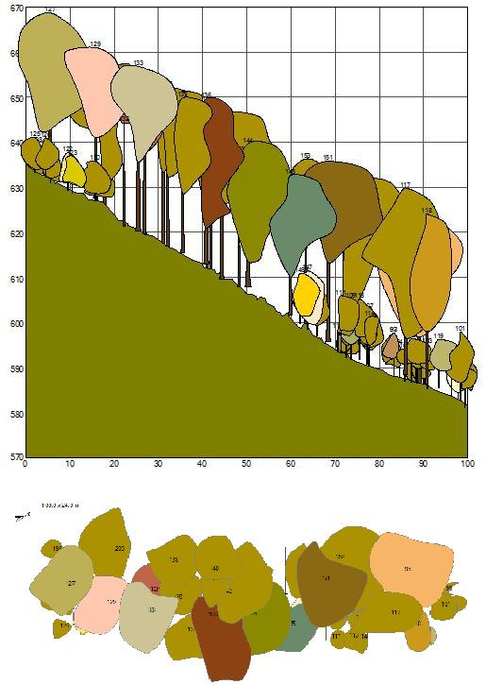

Notice how each tree is numbered, this information corresponds to a table that would contain information about each trees height, volume, the surface area of the canopy, species, etc.
What to do in the forest:
- Start with setting out a baseline of at least 6m, intersecting an interesting looking part of the forest (insure you have at least 3 trees). Expand the baseline 1.5m in both perpendicular directions to the baseline. You should now have a grid that is about 6m by 3m total. Use sticks to indicate the corner posts of each section.

- Measure the position of all the trees in the plot with a diameter over 15cm.

- Next, make a drawing of the crown cover of all the trees by walking away from the stem base until the point where the vertical crown projection ends. Measure this distance to the stem and do this for at least 4 directions. Make a sketch of the crown projection by walking around the periphery of the crown. Check the crown map to see where tree crowns overlap and where the holes in the canopy are and adjust the map accordingly.

- Also measure the diameter for all trees in the plot. Put a compass arrow on the map to indicate where the north is.
- Next, walk away from the tree to a distance about the height of the tree. Measure the tree heights using a clinometer App on your phone and the tangent function on a calculator.

- Record the species.

 | Poor | Reasonable | Awesome
Diagrams | Inaccurate. Trees poorly depicted, no artistic merit. Scale does not work. | Accurate. Trees all depicted in diagram. Some artistic merit. Scale is reasonable. | Accurate. Trees are depicted expertly in diagram. Artistic merit exceptional. Scale is perfect.
Data Collection | Incomplete. Some data forgotten or missing. | Mostly complete. All data asked for has been collected. | Exceptional. Data collection goes beyond what the project required.
Calculations | Many mistakes made. Many errors in formulas and calculations. | Minor mistakes. | No mistakes.
Intangibles | Not very pleasing to the eye. Needs improvements if it is to be shared among your classmates. | Pleasing to the eye. Your classmates want to look at your project. | Incredible. You should be teaching people how to do this professionally.
What to do in the classroom:
- Calculate an appropriate scale to use for the piece of paper you have chosen. This scale may be different vertically vs. horizontally (ie. Your scale may be 10cm=100cm horizontally, but 10cm=200cm vertically). Remember, both images should fit on the same piece of paper. Make sure your scale is shown on the image.

- Calculate Radius of each tree from the measured diameter you recorded in the forest.

- Calculate the surface area covered by the ‘crown’ of each tree. For this purpose assume they are circular.

- Calculate the volume of wood in each tree. For this purpose assume all the trees are inverted cones.

- Draw and number the trees in your forest, referencing the information in the associated table.

