SOUTH DELTA SECONDARY
Cost $175
Junior Girls Volleyball Tournament
October 19th and 20th
(Co-hosted by Sands Secondary)
Pool A | Pool B | Pool C | Pool D | Pool E
1. Rich Christian | 5. EMS A | 9. STA | 13. Handsworth B | 17. Westview
2. Elgin A | 6. Handsworth A | 10. EMS B | 14. North Sur B | 18. Elgin B
3. SDSS A | 7. Seaquam | 11. McMath | 15. Fleetwood | 19. SDSS B
4. Centennial | 8. Moscrop | 12. WR Christian | 16. Langley Fund | 20. North Sur A

Oct.19 at SDSS (courts 1,2,3) Oct.19 at Sands (courts 4,5)
 | Court 1 | Court 2 | Court 3 |  | Court 4 | Court 5
3:15 | 1v2 | 5v6 | 9v10 |  | 13v14 | 17v18
4:15 | 6v7 | 2v3 | 10v11 |  | 14v15 | 18v19
5:15 | 5v8 | 1v4 | 9v12 |  | 13v16 | 17v20
6:15 | 9v11 | 5v7 | 1v3 |  | 13v15 | 17v19
7:15 | 10v12 | 6v8 | 2v4 |  | 14v16 | 18v20
8:15 | 3v4 | 7v8 | 11v12 |  | 15v16 | 19v20

Oct.20 at SDSS (courts 1,2,3) Oct.20 at Sands (courts 4,5)
 | Court 1 | Court 2 | Court 3 |  | Court 4 | Court 5
8:30 | D2vB3 | A2vE2 | C2vA3 |  | D3vC4 | E4vB4
10:00 | B2vE1 | Game 5 | Game 7 |  | C3vD4 | E3vA4
11:30 | Game 8 | Game 13 | Game 14 |  | Game 5 | Game 8
1:00 | Game 6 | Game 15 |  |  | Game 9 | Game 6
2:30 | Game 9 | Game 10 |  |  | Game 7 | Game 10
4:00 | Game 11 | Game 12

GAME RULES:
- Every Team is guaranteed 4 matches (most will get 5 games).

- ROUND ROBIN games will be 2 matches to 25 with a cap at 27. Total games won will determine placing in pool. 1st and 2nd will go to Gold Playoffs, 3rd and 4th to Silver Playoffs (In pools A and B, 3rd will go to the Gold Playoffs).

- In the event of a pool result tie, the tie breakers will be:
  - Head to Head
  - Total points for
  - Total points against
  - Coin Toss

- Playoff games will be best of 3. First 2 games to 25, no cap. If necessary, a third game will be played to 15, no cap.
- Warm up time will be 4 and 4 (5 and 5 if time allows).

- Games WILL begin earlier than scheduled if the court is available.

KEEP IN MIND:
- Referees are experienced Senior Volleyball players from Sands and SDSS. They have refereed before and have been trained BUT they are still students. As coaches and adults, please keep this in mind. We will have a down and up ref for each game.

- Teams are expected to provide lines people and scorekeepers.

CONTACT:
Dan Burgess, SDSS Volleyball, 750 53rd st, Delta,
dburgess@deltasd.bc.ca
604-943-7407 (School)
At SDSS Saturday:

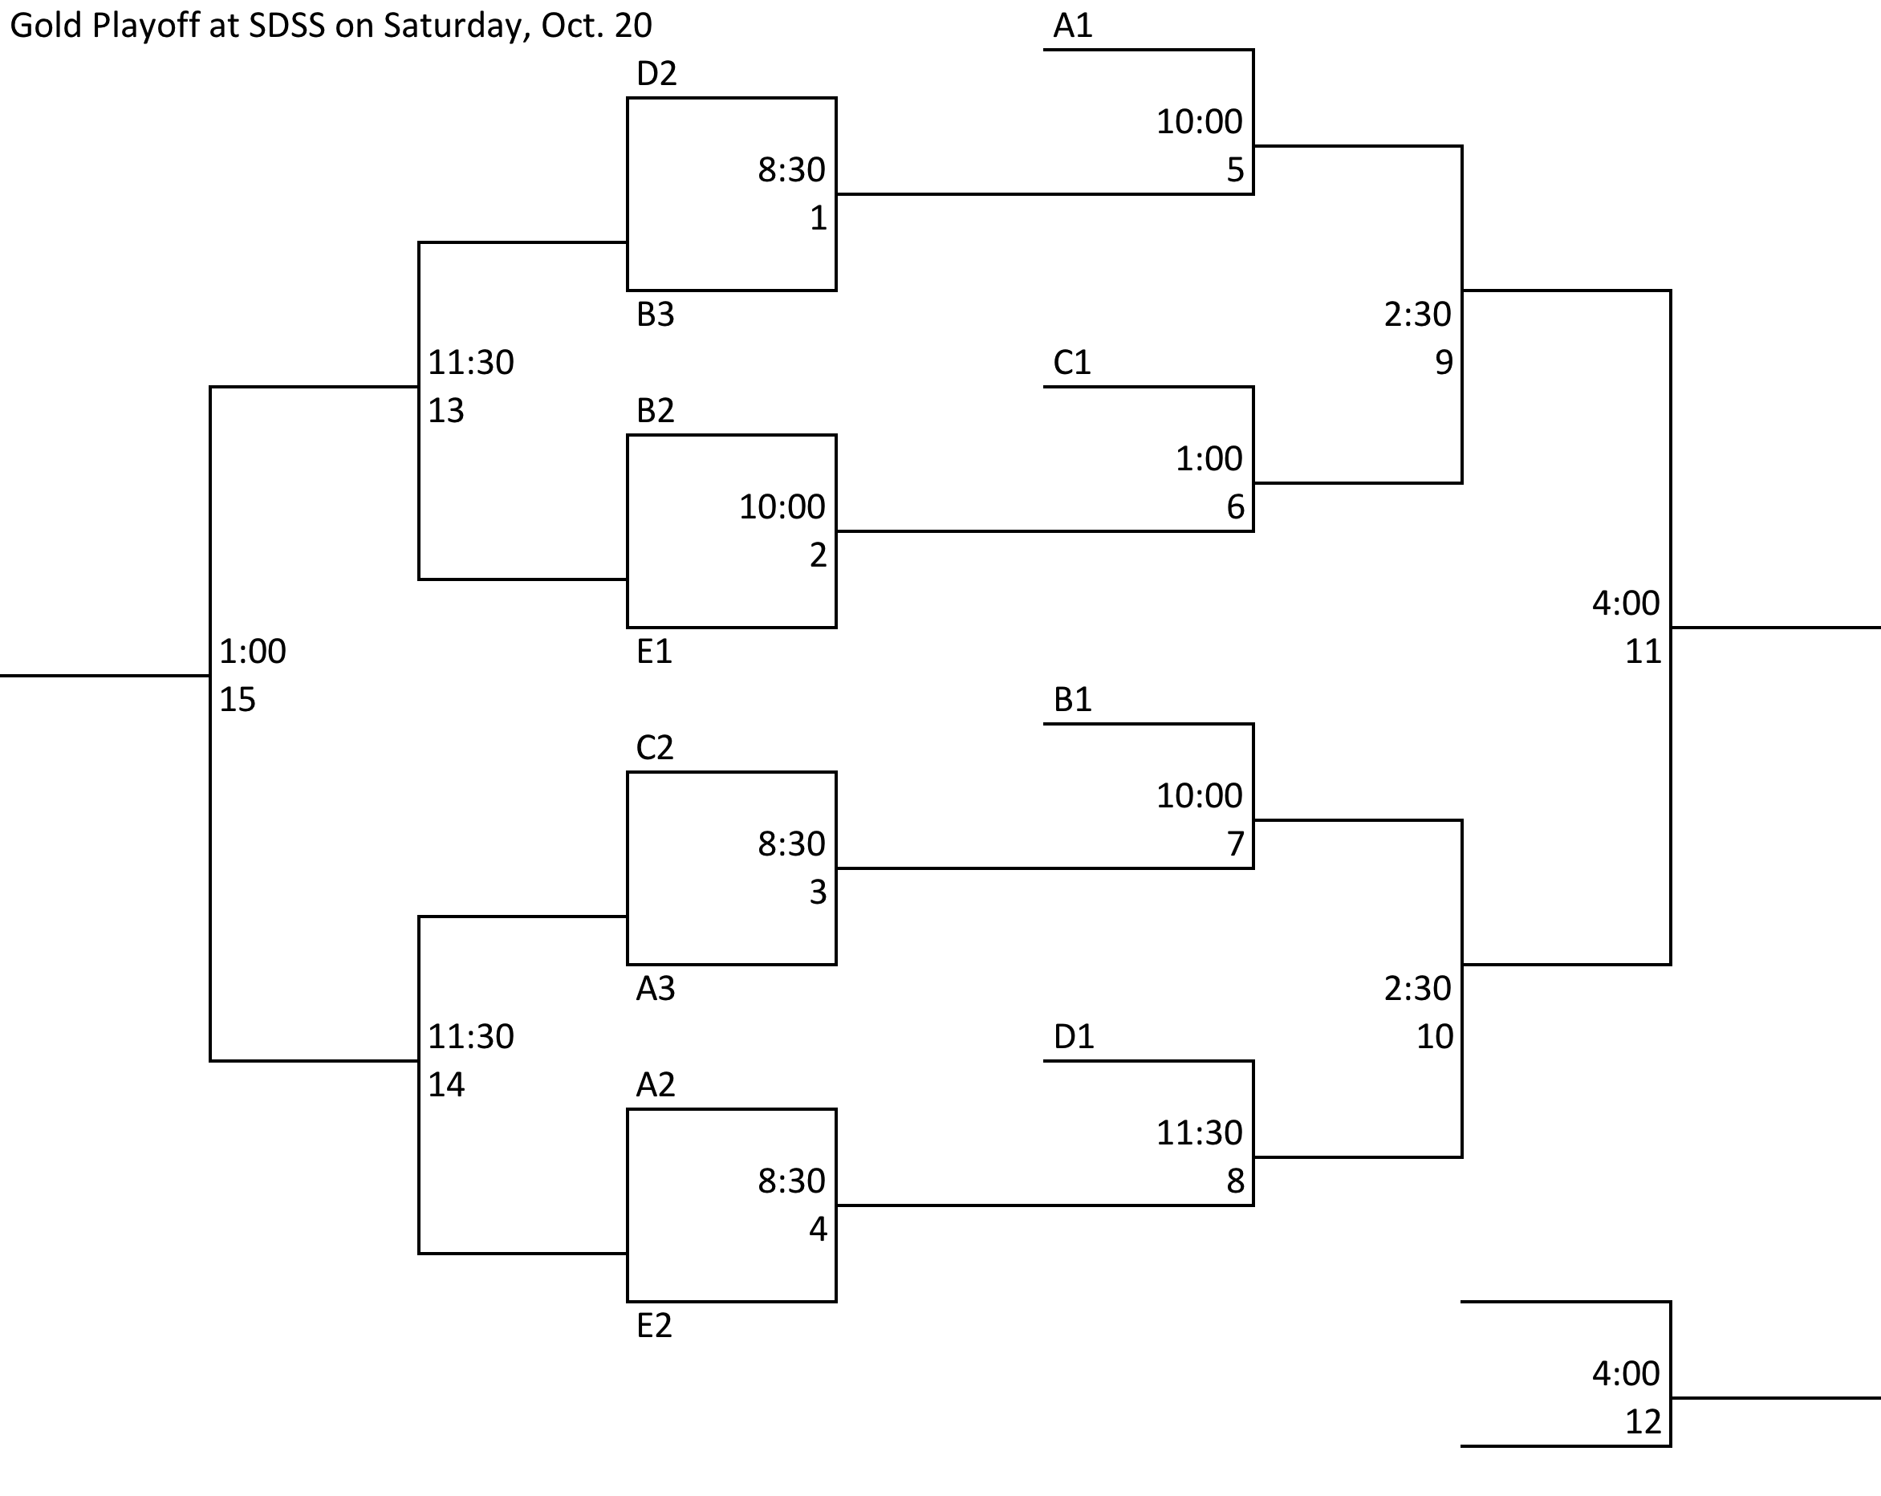

At Sands Secondary on Saturday:
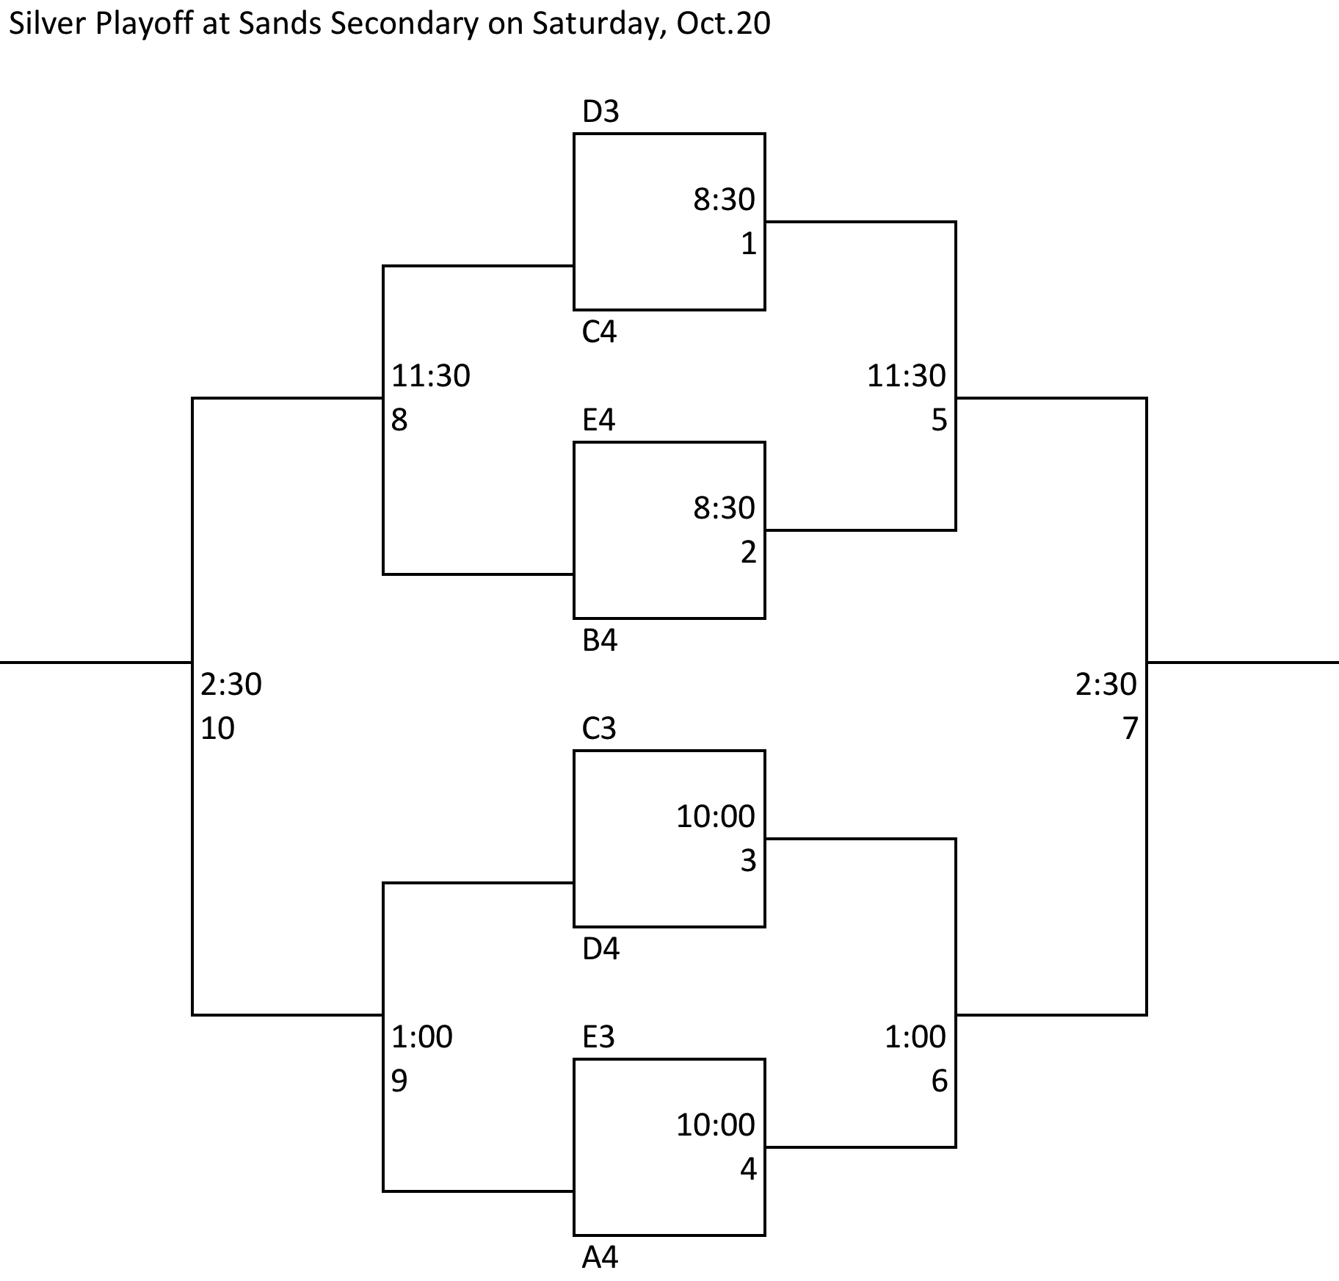

Sands Secondary is located at 10840 82nd ave, North Delta

South Delta Secondary is located at 750 53rd st, Tsawwassen

If you need accommodation, contact me.

