SOUTH DELTA SECONDARY
Cost $175
Junior Girls Volleyball Tournament
October 18th and 19th
(Co-hosted by Sands Secondary)
Pool A | Pool B | Pool C | Pool D | Pool E
1. Langley Chr. | 5. St. Thom Aqu. | 11. Surrey Chr | 15. Langley Fnd 1 | 19. Seaquam
2. EMS | 6. North Surrey | 12. SDSS 1 | 16. Tweedsmuir 1 | 20. Handsworth 1
3. Elgin 2 | 7. McMath 10’s | 13. DW Poppy | 17. WRCA | 21. Sands
4. SDSS 2 | 8. Langley Fnd 2 | 14. McMath 9’s | 18. Handsworth 2 | 22. Tweedsmuir 2
 | 9. Richmond Chr
 | 10. Elgin 1

Oct.18 at SDSS (courts 1,2,3) Oct.18 at Sands (courts 4,5)
 | Court 1 | Court 2 | Court 3 |  | Court 4 | Court 5
3:30 | 1v2 | 5v6 | 11v12 |  | 15v16 | 19v21
4:30 | 3v4 | 5v7 | 13v14 |  | 17v18 | 21v22
5:30 | 1v3 | 6v7 | 11v13 |  | 15v17 | 19v20
6:30 | 2v4 | 8v9 | 12v14 |  | 16v18 | 20v22
7:30 | 1v4 | 8v10 | 11v14 |  | 15v18 | 19v22
8:30 | 2v3 | 9v10 | 12v13 |  | 16v17 | 20v21

Oct.19 at SDSS (courts 1,2,3) Oct.19 at Sands (courts 4,5)
 | Court 1 | Court 2 | Court 3 |  |  | Court 4 | Court 5
8:30 | 5v10 | 6v9 | 7v8 |  | 8:30 | Game 16 | Game 17
9:30 | Game 1 | Game 2 | Game 3 |  | 10:00 | Game 18 | Game 19
11:00 | Game 4 | Game 5 | Game 6 |  | 11:30 | Game 20 | Game 21
12:30 | Game 7 | Game 8 | Game 9 |  | 1:00 | Game 22 | Game 23
2:00 | Game 10 | Game 11 |  |  | 2:30 | Game 24 | Game 25
3:30 | Game 12 | Game 13 |  |  | 4:00 | Game 26 | Game 27
5:00 | Game 14 | Game 15

GAME RULES:
- Every Team is guaranteed 4 matches (20 teams will get 5 games).

- ROUND ROBIN games will be 2 matches to 25 with a cap at 27. Total games won will determine placing in pool. 1st and 2nd will go to Gold Playoffs, 3rd and 4th to Silver Playoffs (In pool B, 3rd and 4th will go to the Gold Playoffs while 5th and 6th will go to the Silver Playoffs).

- In the event of a pool result tie, the tie breakers will be:
  - Head to Head
  - Total points for
  - Total points against
  - Coin Toss
- Playoff games will be best of 3. First 2 games to 25, no cap. If necessary, a third game will be played to 15, no cap.
- Warm up time will be 4 and 4 (5 and 5 if time allows).

- Games WILL begin earlier than scheduled if the court is available.

KEEP IN MIND:
- Referees are experienced Senior Volleyball players from Sands and SDSS. They have refereed before and have been trained BUT they are still students. As coaches and adults, please keep this in mind. We will have a down and up ref for each game.
- Teams are expected to provide lines people and scorekeepers.

CONTACT:
Dan Burgess, SDSS Volleyball, 750 53rd st, Delta,
dburgess@deltasd.bc.ca
604-943-7407 (School)
At SDSS Saturday:
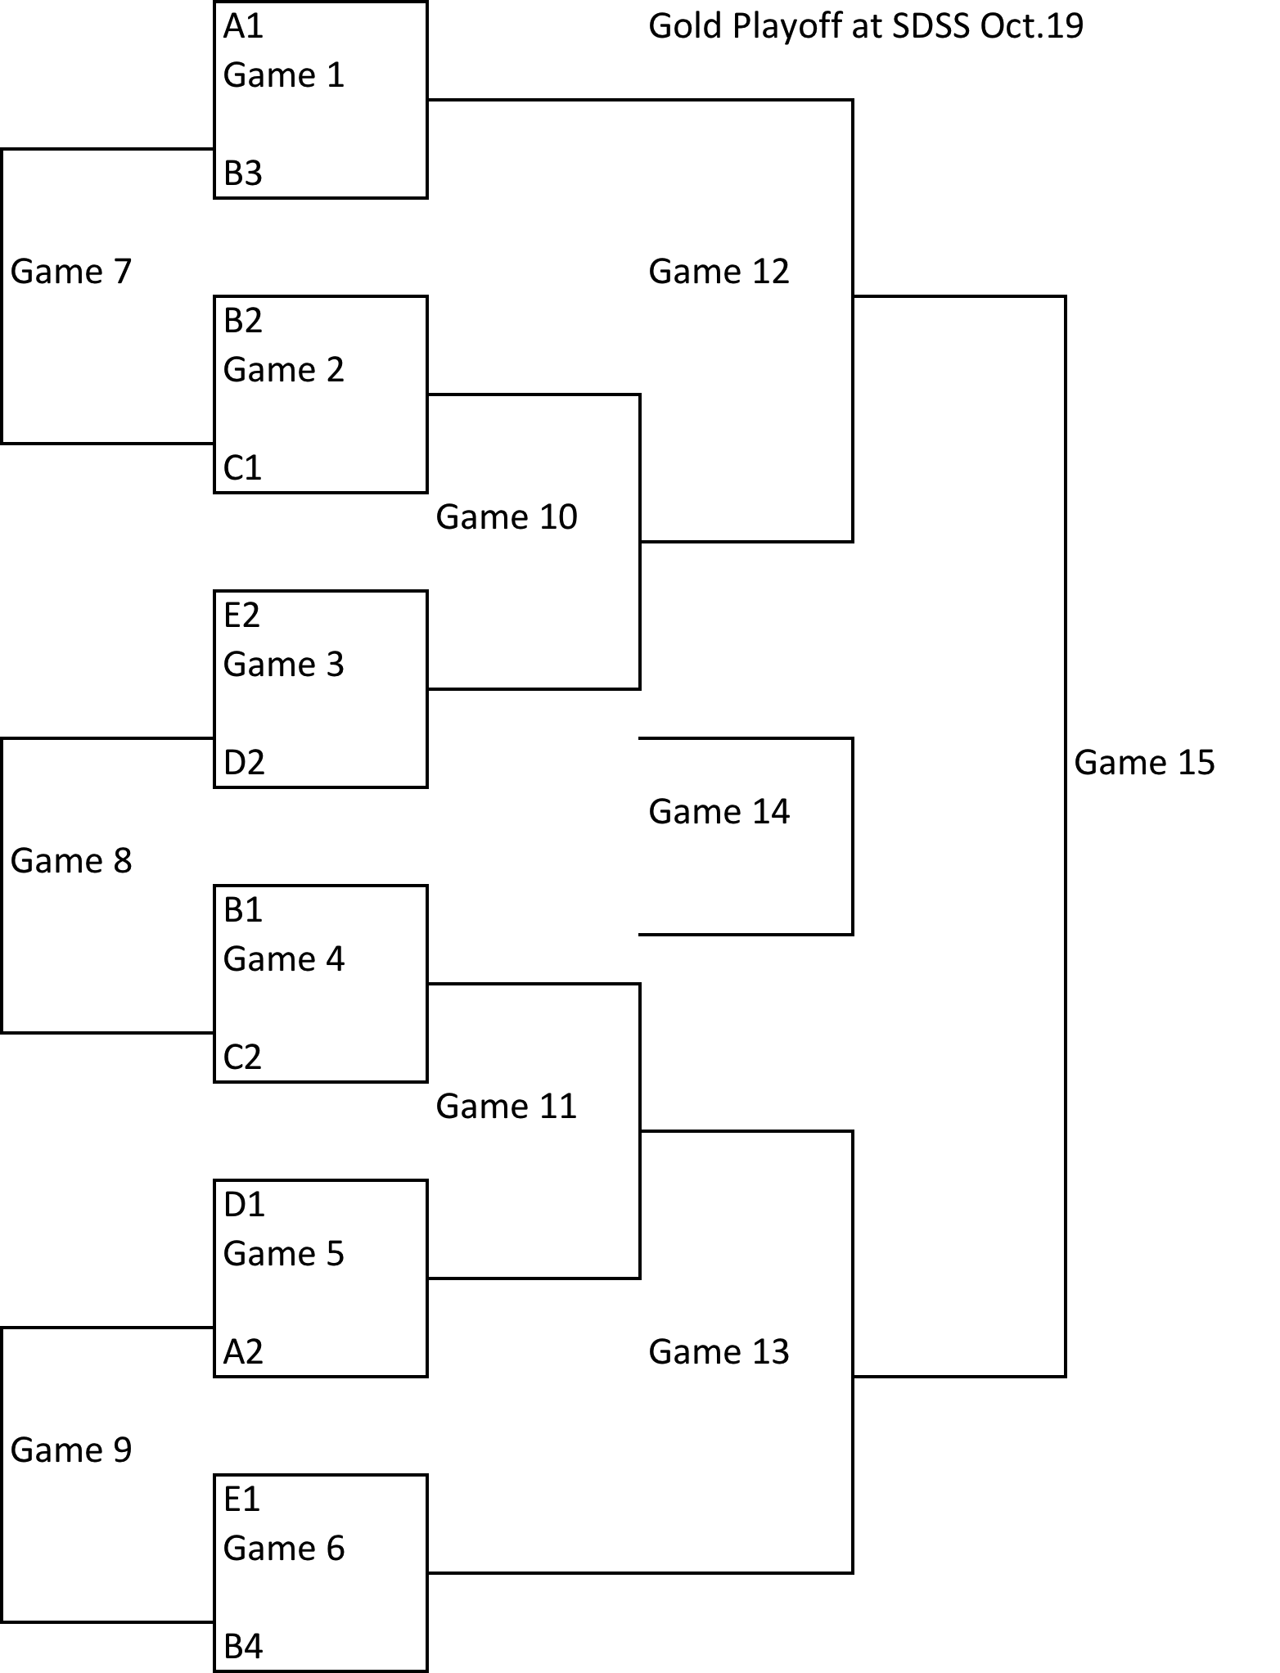

At Sands Secondary on Saturday:
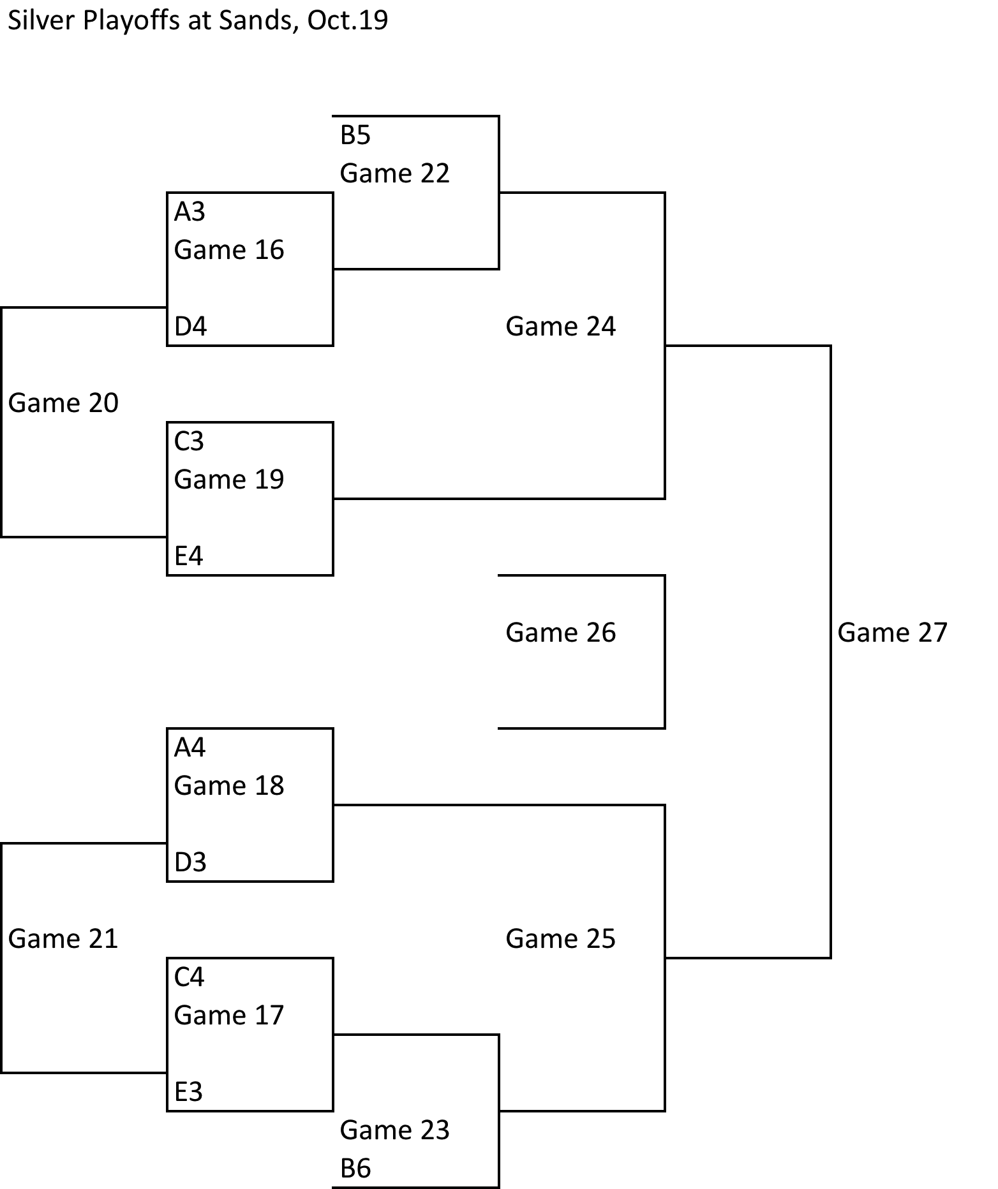

Sands Secondary is located at 10840 82nd ave, North Delta

South Delta Secondary is located at 750 53rd st, Tsawwassen

If you need accommodation, contact me.

